**Week 7 Solutions**

**React**

**9. ReactJS-HOL** .

Create a React Application named “cricketapp”

The code and the folder structure is attached in the **Week 7/** **cricketapp** folder

**Output :-**

**Chrome –** [**http://localhost:3000/**](http://localhost:3000/)

**When Flag = true**

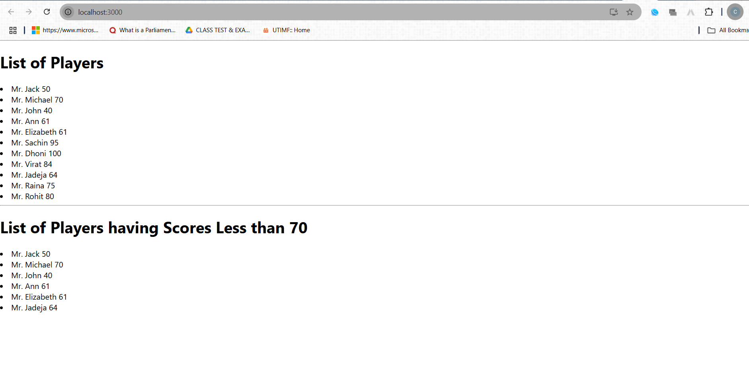

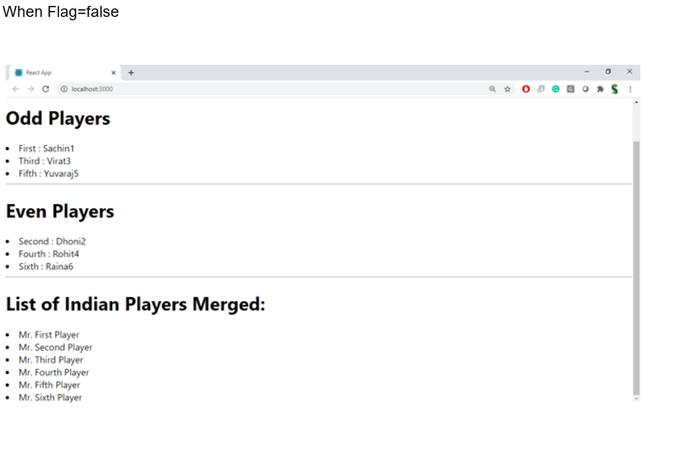

**The hands on file and folder is attached along with it**